Solution to every third end-of-chapter problem
Basics of Engineering Economy, 2nd edition
Leland Blank and Anthony Tarquin

Chapter 14

Alternative Evaluation Considering

Multiple Attributes and Risk

14.1 W_{i} = 1/6 = 0.1667

14.4 (a) Score by attribute with 10 for most important

Logic: #1: 0.90(#5); W₁ = 0.90(10) = 9
#2: 0.10(#5); W₂ = 0.10(10) = 1
#3: 0.3(#5); W₃ = 0.30(10) = 3
#4: 2(#3); W₄ = 2(3) = 6
#5: highest score: W₅ = 10
#6: 0.8(#4); W₆ = 0.80(6) = 4.8

Attribute Importance
1 9.0
2 1.0
3 3.0
4 6.0
5 10.0
6 4.8
33.8

(b) Normalized weights, W_{i} = Score/33.8

Attribute W_{i______}
1 9/33.8 = 0.27
2 1/33.8 = 0.03
- 3/33.8 = 0.09
4 6/33.8 = 0.18
5 10/33.8 = 0.30
6 4.8/33.8 = 0.14

14.7 Estimates are for the future in engineering economic evaluations. Decision making under
risk is, therefore, always present in any conclusion.

14.10 Determine the probability values for N.

N 0 1 2 3 4_ ≥5_
P(N) 0.12 0.56 0.26 0.032 0 .022 0.006

(a) P(N=0 or 1) = P(N=0) + P(N=1) = 0.12 + 0.56 = 0.68

Percentage is 68% of the households

(b) P(N = 1or 2) =0.56 + 0.26
= 0.82 (82%)

(c) P(N > 3) = P(N=4) + P(N≥5) = 0.022 + 0.006
= 0.028 (2.8%)

14.13 (a) Use Equation [14.5] to find E(X).

Cell,
X_{i}, $ P(X_{i}) X_{i} × P(X_{i}), $
600 0.06 36
800 0.10 80
1000 0.09 90
1200 0.15 180
1400 0.28 392
1600 0.15 240
1800 0.07 126
2000 0.10 200
1.00 1344

Sample expected value: E(X) = $1344

(b) Construct a graph with bars at $600, $800, ..., $2000 each at the height of the P(X_{i})

value. Show the E(X) = $1344 value on the graph.

14.16 As an example, a sample of 100 values generated the following results:

(a) = AVERAGE(A1:A100) resulted in 49.2532; very close to 50

(b) = STDEV(A1:A100) resulted in 28.08; very close to 28.87

14.19 A simulation similar to Example 14.6 is performed. MARR varies from 7% to 10% with a 0.25 probability each. Use a lookup table for MARR (columns E and F) coupled with the RAND() function. For CFAT, use RANDBETWEEN(4000,7000). PW values (column M) for the simulation shown are positive 23 of the 30 trials.

Conclusion: The project appears economically viable under both certainty and risk.

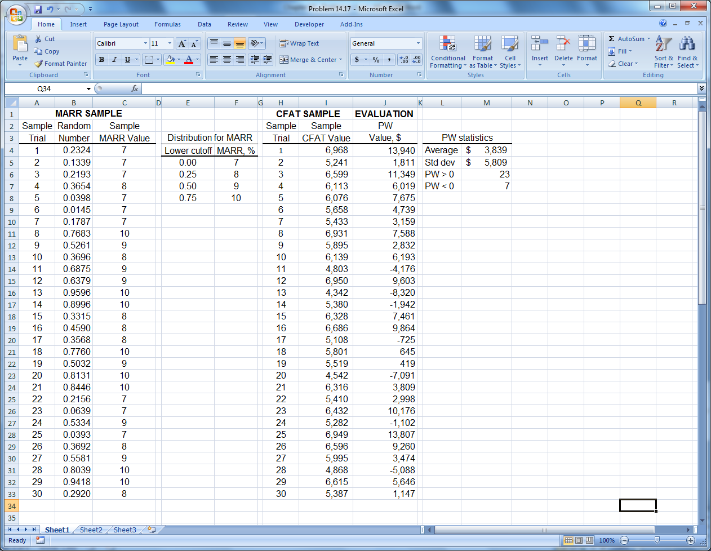

14.22 W_{env} = 50/(100 + 75 + 50) = 50/225 = 0.22

Answer is (c)

14.25 Answer is (c)

14.28 Reading #5 is missing

X = 79 = (81 + 74 + 83 + 66 + x₅)/5

395 = 304 + x₅

x₅ = 91

2 values (66 and 91) are outside the limits

Answer is (b)

